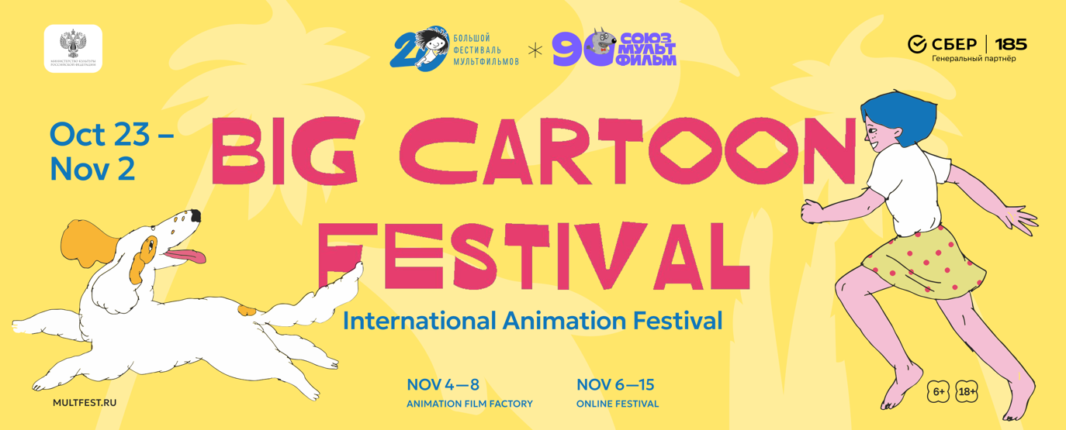

The Big Cartoon Festival (BCF), the largest international animation festival in Russia, will be held for the twentieth time in Moscow from October 23 to November 2, 2026. The online version of the festival will run from November 6 to 15 and will be accessible throughout Russia. The Cartoon Factory will run from November 4 to 8.

BCF is being held jointly with "Soyuzmultfilm" Studio with the support of the Russian Ministry of Culture. The general partner of the event is SBER.

This fall, the BFM will bring together audiences, directors, and artists from around the world for the twentieth time for a major celebration of animation! The program includes hundreds of films for children and adults, Russian and international premieres, highlights from major global festivals, works by renowned masters and debuts by young directors, as well as meetings with creators, exhibitions, lectures, professional discussions, and master-classes.

The festival will open with the Chinese fantasy film "Nobody / Little Demons’ Journey to the West". Four shape-shifting demons – a boar, a weasel, a toad, and a gorilla – set out on a journey in hopes of a better life. In their world, they are small, subservient creatures, planning no heroic deeds, but it is this unlikely group that proves capable of true courage. This funny and touching story is based on the classic novel "Journey to the West," and its landscapes are created using ink on rice paper.

The feature-length competition features seven films from Belgium, Brazil, Spain, China, and France. In addition to the opening film, there will be Sebastien Laudenbach's "Vive Carmen! (Carmen, l'oiseau rebelle)", in which homeless teenagers try to save Carmen from her prophesied death. In "The Treasure of Barracuda (El tesoro de Barracuda)", which won the Brussels Film Festival Audience Award, a young girl finds herself on a pirate ship and suddenly finds herself indispensable thanks to her ability to read. The film adaptation of the child soldier novel "Allah Is Not Obliged" tells the story of war in Africa with an unexpected humor that makes the story even more terrifying. Also screening will be the Chinese legend "The Story about Fire", the fantasy adventure "Muyi (Muyi, la légende du village des femmes)" and the road movie "Son of a Bitch".

Of more than 1,800 submissions, approximately 140 works were selected for the short film competition, roughly equally divided between Russian and international submissions. The international program boasted a broad geographic reach, including winners of major global festivals and particularly notable French and Chinese animation. There will be documentaries, experimental films, children's films, and a surprising number of comedies and horrors. The Russian competition is still very young: half of its program consists of student works.

Three juries will discuss the films and select the winners. In the international short film competition, these will be directors Polina Campioni and Ivan Bondarenko, and Israeli artist and director Gali Edelbaum of the duo "Nir and Gali". Russian films will be judged by director Ivan Khanzhin, artist and illustrator Alisa Yufa, and animator Svetlana Zimina. The feature films will be judged by screenwriter Vladimir Geller, Canadian director and animator Matthew Lyon, and artist and director Valentin Olshvang.

Last year, the BCF launched a business program for animation industry professionals. This year, four panel discussions will cover topics such as how to pitch a new project and raise funding, enter the international market, where to study animation, and how to build a career in it.
The BCF anniversary coincides with the 90th anniversary of "Soyuzmultfilm", and to mark this anniversary, the festival will screen films from the studio across the years. Beloved festival traditions will also be present. Free children's screenings will be held in Moscow cinemas, libraries, and cultural centers. And for those who can't get enough cartoons and don't want to leave after the last screening, there will be "Night of Animation".
The Cartoon Factory will reopen and be operational. From November 4th to 8th, at the Palace of Pioneers on Sparrow Hills, anyone can try their hand at being a screenwriter, artist, animator, composer, or director. In its workshops, children and adults will invent stories, bring plasticine characters to life, paint with sand, and film and voice-over their own movies.
The Grand Cartoon Festival will traditionally take place at Moscow venues and then continue online. From November 6 to 15, its programs will be available for viewing across Russia on the multfest.online platform.
Twenty years ago, we created the Cartoon Factory. Since then, the festival has developed its own audience, friends, and habits. Some come to the Russian premieres every year, others trust unfamiliar names in the international program, and some once brought their children to the Cartoon Factory and now come to see their films. This year will be a chance to remember all of this and see what's new in the world of animation.

CONTACTS
Official website of the festival: http://multfest.ru
Telegram channel: t.me/multfest

Media accreditation, PR and advertising:
Katarzyna Belkova: belkovakatie@gmail.com

For cooperation issues:
Victor Fedoseyev: v.fedoseev@multfest.ru

Pics and logo you can find here: https://multfest.ru/

